10/3/23

Griffin Rzonca

ECE 445

10/3 Meeting with Jason

1. Audio Processing output to gate driver circuit
2. Gate driver circuit
   1. Do we need de-glitching?
   2. Circuit diagram

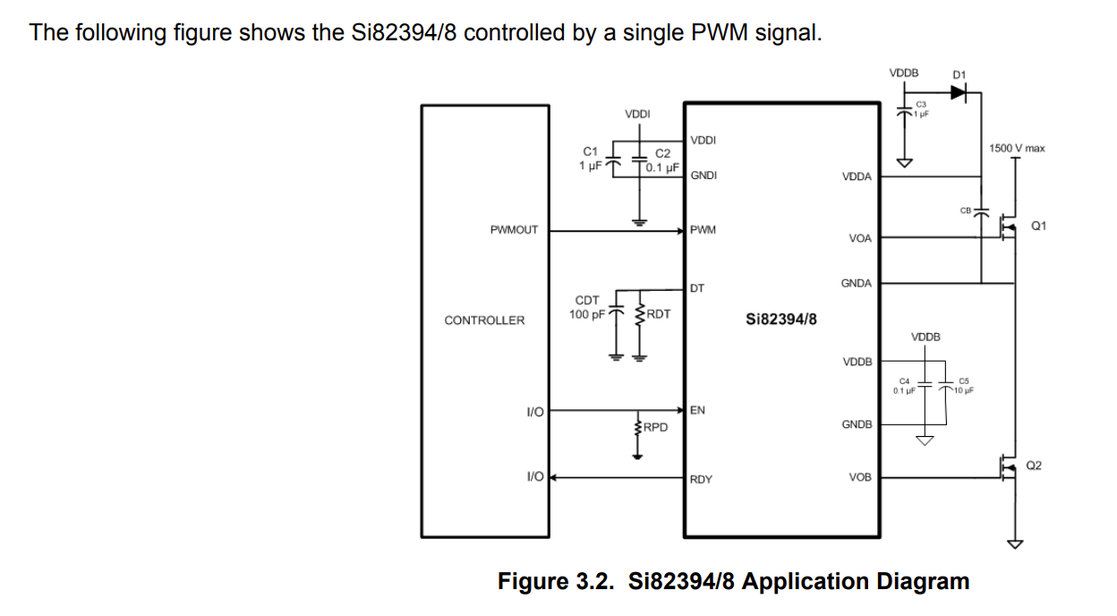

* Jason may have some 600V 1mF caps for us
* Look at ESL of speaker caps, values use 100kHz
* For schematic, include footprints, connectors, etc
* Add 3-prong to board connectors
* Look at 469 manual for bootstrap cap values
* Deglitching:
  + Ringing may turn on both logic inputs, may have an internal option to remove ringing in logic signal
  + Leave a spot for a little bit of resistance and capacitance in case we have a ringing problem
* Too much dead time can increase EMI, start with 100ns and mess around with it
* Don't know driver impedance, maybe 50Ohm to ground R to protect from EMI
* Jason doesn't trust coax, other designs don’t use it,
* Vddb should be around the desired Vgs
* Use ceramic for bootstrap cap
* 10uF cap on gate driver can be either, but prefer ceramic
* Look into E-Shop for parts (not ece supply shop)
* Need CFOB number to order things from myece and ece shop, Jason will give us one
* Jason will check out esp32 and a few other uC’s for us